 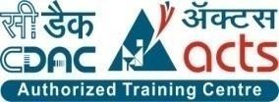

INSTITUTE FOR ADVANCED COMPUTING AND SOFTWARE DEVELOPMENT AKURDI, PUNE

Documentation On

**“STUDENT PORTAL FOR IACSD”**

PG-DAC AUG 2021

*Submitted By:*

**Group No: 50**

**Names & roll numbers**

**Samiksha M. Hogade - 219073**

**Shubham V. Thorat - 219192**

**Mr. Prashant Karhale Mrs. Shilpa pawale mam**

**Centre Coordinator Project Guide**

# Table of Contents

1. Introduction 4

Document Purpose 4

Problem Statement 5

Product Scope 5

Aim & Objectives 6

1. Overall Description 7

Product Perspective 7

Benefits of Society Management System 8

User and Characteristics 8

Operating Environment 9

Design and Implementation Constraints 9

1. Requirements Specification 10

Functional Requirements …………………………………………………………………..11

Non-Functional Requirements 13

External Interface Requirements 14

1. System Diagram 16

Activity Diagram 16

Data Flow Diagram 18

Use Case Diagram 21

ER Diagram 22

1. Table Structure 23

User 23

Assignment 24

Timetable 25

Noticeboard 26

Assignment-answer 26

1. Project Diagrams 29
2. Conclusion………………………………………………………………………..42

Future Scope 42

1. References 43

**List of Figures**

Figure 1 Admin Activity Diagram 11

Figure 2 Faculty Activity Diagram 12

Figure 3 Student Activity Diagram 12

Figure 4 Level 0 Data Flow Diagram 13

Figure 5 Level 1 Data Flow Diagram 13

Figure 6 Level 2 Data Flow Diagram for Admin 14

Figure 7 Level 2 Data Flow Diagram for faculty 14

Figure 8 Level 2 Data Flow Diagram for Student 15

Figure 10 Use Case Diagram 16

Figure 11 ER Diagram 16

# Introduction

The term portal is known as links page which presents information from diverse sources in a unified way. Portals provide a way for enterprises to provide a consistent look and feel with access control and

procedures for multiple applications and databases.

Student portals serve academic institutions in a variety of ways, the most important of which is centralized data administration and accessibility. Faculty will be able to input, maintain, and access student data more simply. Students have a better understanding of their own marking distribution or noticeboards timely.

Institute professionals must enhance their student management skills over time. It is defined as a collection of skills that every teacher develops through time in order to properly manage their students. Getting into the student’s heart is one of the most important aspects of management.

## Document Purpose

Student Information Management System can be used by education institutes to maintain the records of students easily. Achieving this objective is difficult using a manual system as the information is scattered, can be redundant and collecting relevant information may be very time consuming. All these problems are solved using this project.

Enhance Business Processes:

To be able to use internet technology to project to limiting their services to their students and faculty alone, thus it will makes faculty’s work easy.

Online Student-Faculty Management:

A tool through which admin can register students and faculty and provide many functionalities to them. The admin manages the faculty and students.

## Problem Statement

The purpose of this study is to develop a web based online student Portal that as a solution to the problems of the students and faculty currently in the institution. The purpose of this study is aimed to solve the following problems:

1. The problem due to some manual means of operations which easily lead to misplacement or loss of student information.
2. The manual pre-assessment of student is very slow and consumes a lot of time

which causes the delay in completing the marking system.

3. Due to manual means of generating assignment submission and mark distribution, such reports can easily be misplaced or loss. The outcomes from this study will assist the institute to know whether or not the problems of manual handling of students assessment and mismanagement records have been overcome. The level of acceptance and use of student portal system by the user of the institute that will be unraveled in this study will provide a framework for the improvement of student portal at the institute.

## Product Scope

This system is aimed at total user-friendly as well as efficient management of varied tasks. These tasks may range from registering new students, managing students and faculty, conducting mocks, displaying results, tracking attendance which all are essential features necessary for making the management of IACSD effective.

* This includes study on how the daily institute work actually is being done, process involved and opportunity that exist for improvement.
* J2EE Technology used for the development of the application.
* Faculty as well as students who are added by admin will be able to use the system effectively.
* Web-platform means that the system will be available for access 24/7 except when there is a temporary server issue which is expected to be minimal.

## 

## Aims & Objectives

* Main objective behind construction of this portal is to provide single place to students as well as faculty from where they can manage to see information.
* This portal is not only to be useful to students of the institute but also faculty members and administrator of the institute.

Objective:

* This student portal for IACSD project’s objective is of being in significant way by providing most basic and most essential functionalities and features to its users in efficient and effective manner.

Specific goals are: -

* To produce a web-based system that allow the admin to add students as well faculty and provide functionalities to its role.
* To ease admin, faculty, students by providing different functionalities to it.
* Online registration of students
* Maintenance of student and faculty records
* Searching student and faculty records

# Overall Description

## 2,1 Product Perspective:

**2.1.1 Existing system function:**

The website Student portal for IACSD is aimed towards recording a considerable number of student records and needs online assistance for managing records of students. Website is user-friendly, quick to learn and reliable website for the above purpose. Student Information System is intended to be a stand-alone website and it is not depend on the availability of other website. The system will also have an administrator who has full-fledged rights with regards to performing all actions related to control and management of the website.

Only the constraints are:

* Every user must be comfortable using computer.
* All operations are in English so user must have basic knowledge of English.

**2.1.2. PROPOSED SYSTEM**

Product functionality:

Student portal for IACSD provides the features for admin, faculty and student. It includes several functionalities describes as below:

In this student portal system, there are mainly 3 users:

1.Admin:

- Admin can add student and faculty.

- Admin can edit details of student and faculty.

- Admin can also delete details of students as well as faculty.

2.Faculty:

- Faculty can add timetable and view timetable.

- Faculty can add noticeboard and view noticeboard.

- Faculty can view student details also.

- Faculty can upload assignments, also check assignments and can give remarks.

3.Student:

- Students can see timetable uploaded by faculty.

- Students can see noticeboard uploaded by faculty.

- Students also can see the faculty details.

- Students can upload the assignment given by faculty.

This portal can work on any platform like google, Microsoft edge etc.

## 2.2 Benefits of Student portal for IACSD:

## This student portal system solution is fully functional and flexible.

## It is very easy to use.

## This online student management system helps to faculty and admin by streamlining and standardizing the procedures.

## It saves a lot of time and loss of student or faculty information.

## Eco-friendly: The monitoring of the student portal and the overall functionalities becomes easy and includes the least of paper work.

## It increases the efficiency of the management at offering quality services.

## It provides custom features development and support with the application.

## 2.3. Users and Characteristics:

Admin:

* Admin can login to the system.
* Admin can view their own profile, edit own profile and change password.
* View the list students.
* Add new students.
* Admin can delete student details.

Admin can edit student details.

View the list faculty.

Add new faculty

Admin can delete faculty details.

Faculty:

* + Faculty can login to the system.
  + Faculty can view their own profile, edit own profile and change password.
  + View students’ details.
  + Faculty can add timetable.
  + Faculty can view timetable.
  + Faculty can add noticeboard.
  + Faculty can view noticeboard.
  + Faculty can upload assignment for students.
  + Faculty also can edit or delete assignment uploaded by faculty itself.
  + Faculty can view assignments.
  + Faculty can see assignment answers i.e uploaded back by students.
  + Then faculty can give remark and grade to students assignments.

Student:

* + Student can login to the system.
  + Students can view their own profile, edit own profile and change password.
  + View faculty details.
  + Students can view timetable and join lecture or lab from given link.
  + Students can view noticeboard added by particular faculty.
  + Students can upload answer key of assignment uploaded by faculty.

## 2.4. Operating Environment:

**2.4.1 Server Side:**

**Processor:** Intel® Xeon® processor 3500 series

**HDD:** Minimum 500GB Disk Space

**RAM:** Minimum 2GB

**OS:** Windows 8.1, Linux 6

**Database: MySQL**

**2.4.2. Client Side (minimum requirement):**

**Processor:** Intel Dual Core

**HDD:** Minimum 80GB Disk Space

**RAM:** Minimum 1GB

**OS:** Windows 7, Linux

## 2.5. Design and Implementation Constraints:

* The application will use spring boot, JSP, HTML, CSS as main web technologies.
* HTTP and FTP protocols are used as communication protocols. FTP is used to upload the web application in live domain and the client can access it via HTTP protocol.
* Several types of validations make this web application a secured one and SQL Injections can also be prevented.
* Since Student portal for IACSD is a web-based application, internet connection must be established.
* The Student portal for IACSD will be used on PCs and will function via internet or intranet in any web browser.

# 

# 3.Specific Requirement

# 3.1 Functional Requirements:

# -The Admin will be given more powers (add/ update/delete) than other users.

# - It will be ensured that the information entered is of the correct format.

# For example, name cannot contain numbers. In case if incorrect form of information is added, the user will be asked to fill the information again.

# -The system can be accessed anytime.

3.1.1 User Specification

**Admin:**

Admin can add, update and delete faculty and student.

**Faculty:**

Faculty can upload assignments, update noticeboard, add timetable can give remark to submitted student assignment and view student details.

**Student:**

Student can view timetable, can see uploaded assignment by faculty, remark of assignment added by faculty, notice.

Student can also submit assignments on given link faculty.

**MODULE SPECIFICATION**

**Admin:**

* Add faculty:

Admin is the only person who can add faculty details.

* View faculty:

Admin can see faculty details.

* Add student:

Admin is the only person who can add student details.

* View students:

Admin can see student’s details.

* Edit student:

Admin is the only person who can editstudent details.

* Edit faculty:

Admin can edit the details of faculty.

* Delete student:

Admin is the only person who can delete student from list.

* Delete faculty:

Admin can also delete faculty details.

* Display result:

After the exam result submitted by faculty will be displayed by admin.

**Faculty:**

* Add timetable:

Only faculty can create students and faculties daily course timetable. And it will be uploaded on daily basis for both students and faculty.

* View timetable:

Faculty can see the timetable in this module.

* Add Notice-board:

If there is any notice regarding guest lecture etc then only faculty can upload information about that notice prior to the time.

* View Notice-board:

If there is any notice regarding exam, guest lecture etc then only admin can upload information about that notice prior to the time.

* Upload assignment:

Faculty can upload assignments for student.

* View assignment:

Faculty can see who all students has submitted the assignments.

* View student details:

Faculty can see student details.

**Student:**

* View timetable:

This will be one option on Student menu list in which timetable will be displayed which is uploaded by admin.

* View notice:

If there is any notice regarding guest lecture etc. then student can see notice.

* View faculty details:

Students can see faculty details in this section in case they want to contact faculty member.

* Submit assignment:

Students can submit assignments here which are uploaded by faculty.

# 3.2. Non- Functional Requirement :

# - Performance Requirements: The proposed system that we are going to develop will be used as the Chief performance system for providing help to the organization in managing the whole database of the student studying in the organisation. Therefore, it is expected that the database would perform functionally all the requirements that are specified.

# - Safety Requirements: The database may get crashed at any certain time due to virus or operating system failure. Therefore, it is required to take the database backup.

# - Security Requirements: We are going to develop a secured database. There are different categories of users namely Administrator ,Student who will be viewing either all or some specific information form the database. Depending upon the category of user the access rights are decided. It means if the user is an administrator, then he can be able to modify the data, append etc. All other users only have the rights to retrieve the information about database.

## 3.3 External Interface Requirements:

**3.3.1. User Interfaces:**

* + All the users will see the same page when they enter in this website. This page asks the users a email as a username and a password.
  + After being authenticated by correct username and password, user will be redirect to their corresponding profile where they can do various activities.
  + The user interface will be simple and consistence, using terminology commonly understood by intended users of the system. The system will have simple interface, consistence with standard interface, to eliminate need for user training of infrequent users.

**3.3.2. Hardware Interfaces:**

* + No extra hardware interfaces are needed.
  + The system will use the standard hardware and data communication resources.

**3.3.3. Application Interfaces:**

**OS:** Windows 7, Linux

**Web Browser:**

The system is a web-based application; clients need a modern web browser such as Mozilla Firebox, Internet Explorer, Microsoft edge, and Chrome. The computer must have an Internet connection in order to be able to access the system.

**3.3.4 Communications Interfaces:**

* + This system uses communication resources which includes but not limited to, HTTP protocol for communication with the web browser and web server and TCP/IP network protocol with HTTP protocol.
  + This application will communicate with the database that holds all the records of students and faculty information. Users can contact with server side through HTTP protocol by means of a function that is called HTTP Service. This function allows the application to use the data retrieved by server to fulfil the

request fired by the user.

# 4.System Design

## 4.1. Activity Diagram

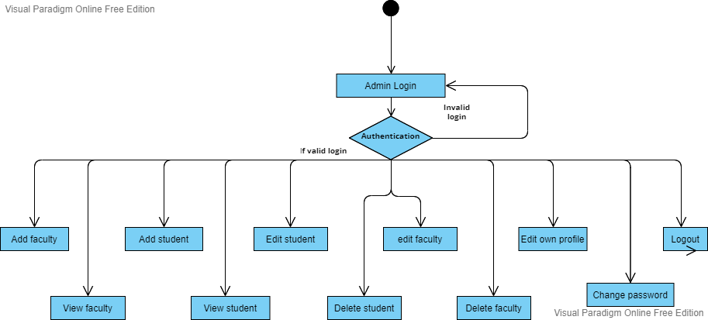

**Figure 1: Admin Activity Diagram**

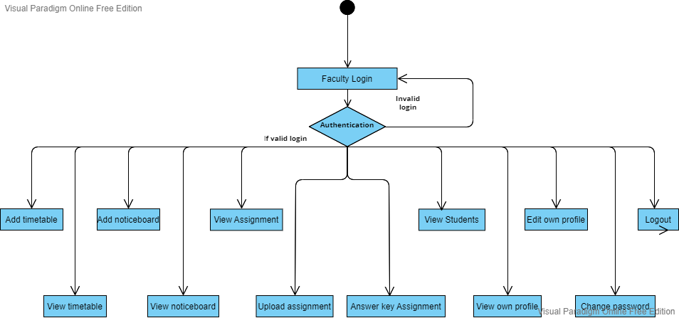

**Figure 2: Faculty Activity Diagram**

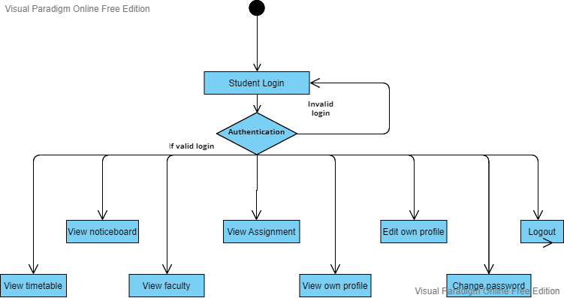

**Figure 3: Student Activity Diagram**

## 4.2. Data Flow Diagram

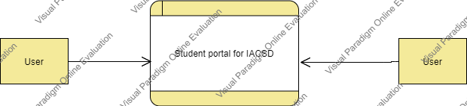

**Figure 4: Level 0 Data Flow Diagram**

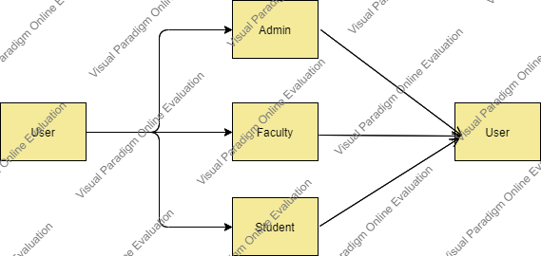

**Figure 5: Level 1 Data Flow Diagram**

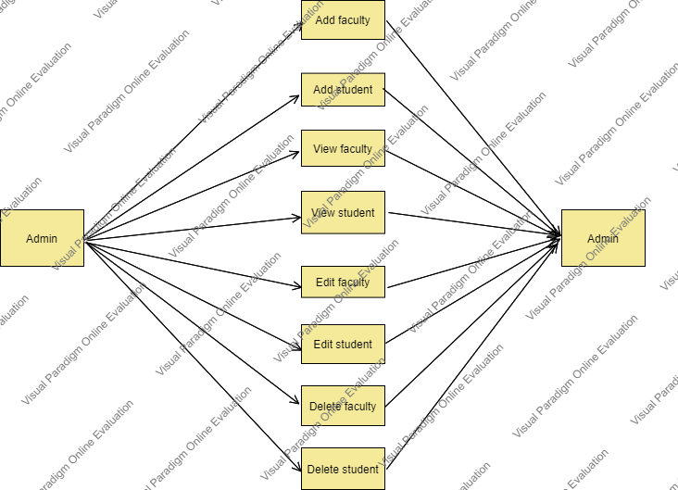

**Figure 6: Level 2 Data Flow Diagram for Admin**

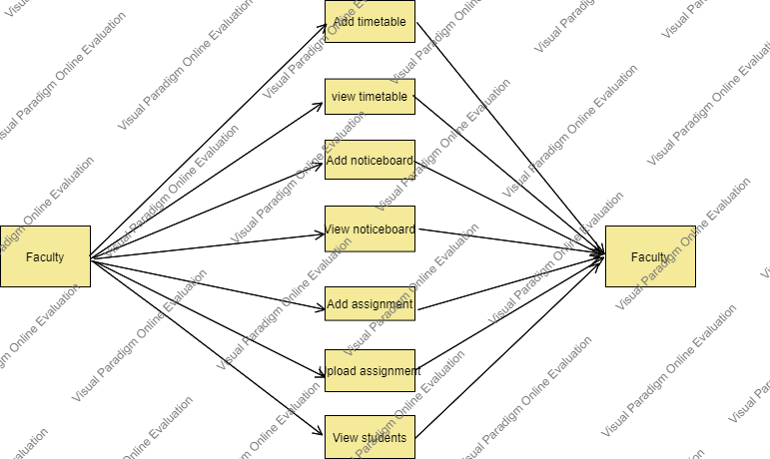

**Figure 7: Level 2 Data Flow Diagram for Faculty**

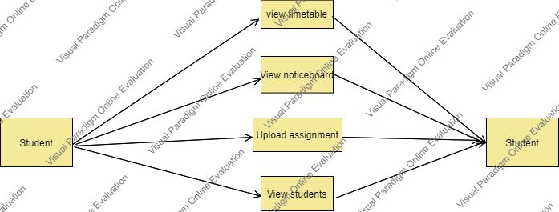

**Figure 8: Level 2 Data Flow Diagram for** **Student**

## 4.3 Use Case Diagram

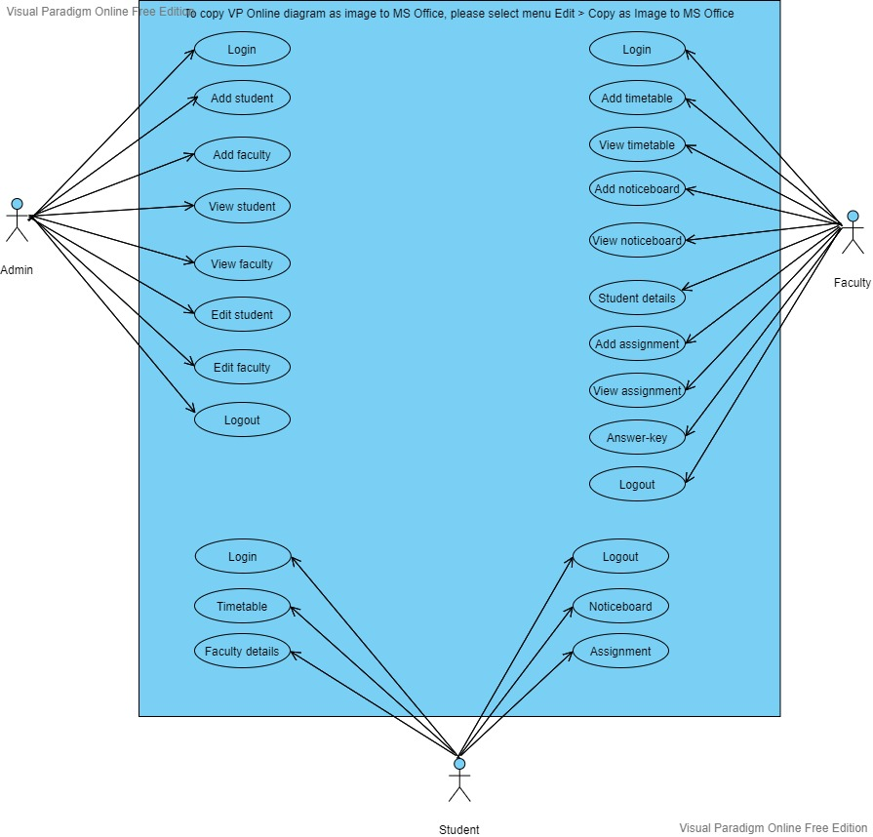

**Figure 9: Level 2 Data Flow Diagram for Watchman**

## 4.4 ERDiagram

## 

# 

# 5. Table Structure

**5.1. User table**

|  |  |  |  |  |
| --- | --- | --- | --- | --- |
| **Sr.** | **Field Name** | **Data type(Size)** | **Constraints** | **Description** |
| **No** |  |  |  |  |
|  |  |  |  |  |
| 1 | id | int(11) | Primary Key | It is store id of each user. |
|  |  |  |  |  |
| 2 | fullname | varchar(255) | Null | It is store user’s full name. |
|  |  |  |  |  |
| 3 | email | varchar(255) | Null | It is store email id of the user |
|  |  |  |  |  |
| 4 | address | varchar(255) | Null | It stores address of the user. |
|  |  |  |  |  |
| 5 | dob | varchar(255) | Null | It stores birthdate of the user. |
|  |  |  |  |  |
| 6 | mobileno | varchar(255) | Null | It is store mobile no of user. |
|  |  |  |  |  |
| 7 | password | varchar(255) | Null | It is password of user in encrypted format. |
|  |  |  |  |  |
| 8 | role | varchar(255) | Null | It stores role of that user. |

**5.2. Assignment table**

|  |  |  |  |  |
| --- | --- | --- | --- | --- |
| Sr. No | **Field Name** | **Data type(Size)** | **Constraints** | **Description** |
|  |  |  |  |  |
| 1 | id | int(11) | Primary Key | It is store Assignment Id |
|  |  |  |  |  |
| 2 | facultyid | Int(10) |  | It is store faculty id who assigned that assignment |
|  |  |  |  |  |
| 3 | Faculty_name | varchar(255) |  | It is store Faculty name |
|  |  |  |  |  |
| 4 | Subject_name | varchar(255) |  | It is store subject name . |
|  |  |  |  |  |
| 55 | Description | varchar(255) |  | It is store description about that assignment if faculty has given any. |
| 56 | Assigned_File | varchar(255) |  | It is to submit assignment |

**5.3. Timetable table:**

|  |  |  |  |  |
| --- | --- | --- | --- | --- |
| Sr. No | **Field Name** | **Data type(Size)** | **Constraints** | **Description** |
| 1. | Id | bigint | Primary key | It stores Id of the timetable . |
| 2. | Faculty_id | bigint |  | It stores faculty id. |
| 3. | Faculty_name | varchar(255) |  | It stores the faculty name. |
| 4. | Subject_name | varchar(255) |  | It stores the subject name. |
| 5. | Start_time | varchar(255) |  | It stores start time of the lecture/lab. |
| 6. | End_time | varchar(255) |  | It stores end time of the lecture/lab. |
| 7. | App | varchar(255) |  | It stores the app on which platform faculty is taking lecture. |
| 8. | Date | varchar(255) |  | It stores date for which that particular timetable is assigned. |
| 9. | link | varchar(255) |  | It stores link for the lecture/lab. |

**5.4. Noticeboard table**

|  |  |  |  |  |
| --- | --- | --- | --- | --- |
| **Sr. No** | **Field Name** | **Data type(Size)** | **Constraints** | **Description** |
|  |  |  |  |  |
| 1 | id (Primary) | bigint(11) | Primary Key | It is store notice id |
|  |  |  |  |  |
| 2 | Faculty_id | bigint(10) |  | It is faculty id who has given the notice. |
|  |  |  |  |  |
| 3 | Faculty_name | varchar(255) |  | It is faculty name . |
| 4 | date | varchar(255) |  | It is Date of exam |
| 5 | description | varchar(255) |  | It gives the notice. |
|  |  |  |  |  |

**5.5. Assignment answer table:**

|  |  |  |  |  |
| --- | --- | --- | --- | --- |
| **Sr. No** | **Field Name** | **Data type(Size)** | **Constraints** | **Description** |
| 1. | Id | bigint | Primary key | It stores primary key . |
| 2. | Faculty_id | Bigint |  | It stores faculty id to which assignment will be submitted. |
| 3. | Assignment_id | Bigint |  | It stores assignment id |
| 4. | Subject_name | Varchar(255) |  | It stores subject name. |
| 5. | User_id | Bigint |  | It stores user id means here student id. |
| 6. | User_name | Varchar(255) |  | It stores user name means student name who submitted the assignment. |
| 7. | Filename | Varchar(255) |  | It stores the filename. |
| 8. | Grade | Varchar(255) |  | It stores grade given by faculty. |
| 9. | remark | Varchar(255) |  | It stores remark . |

**6.Project Diagrams**

**Front Page :**

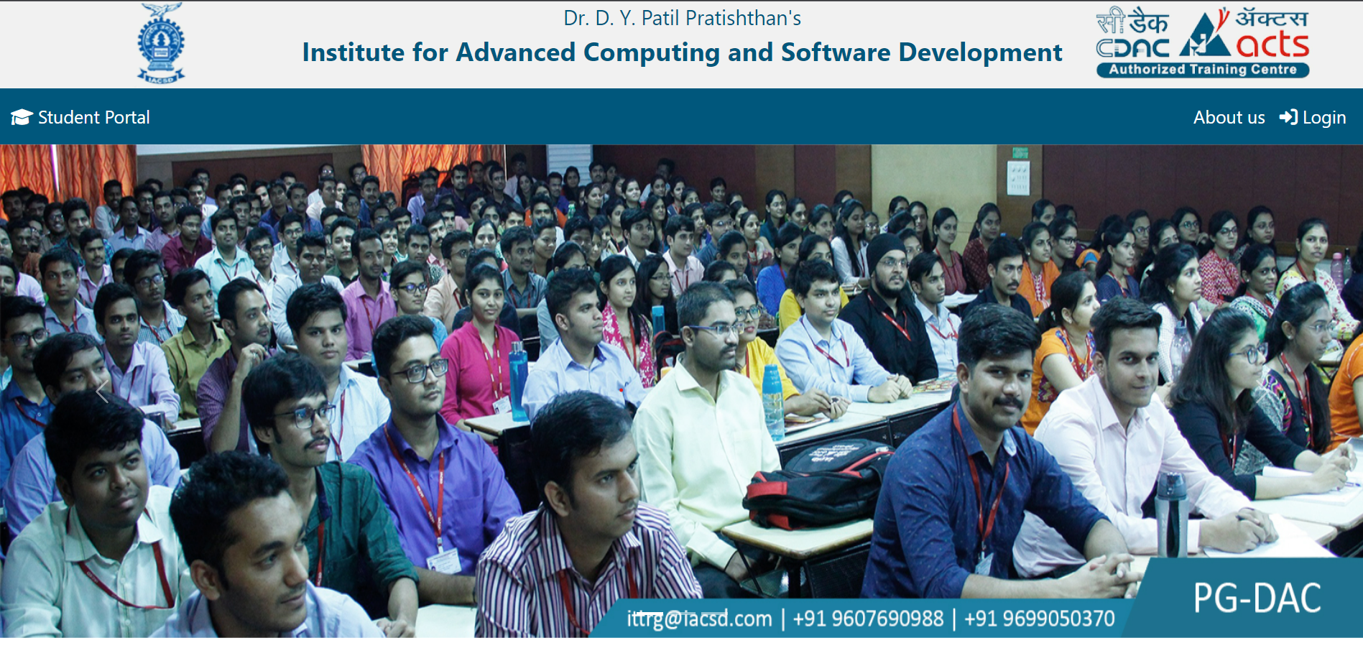

**About page :**

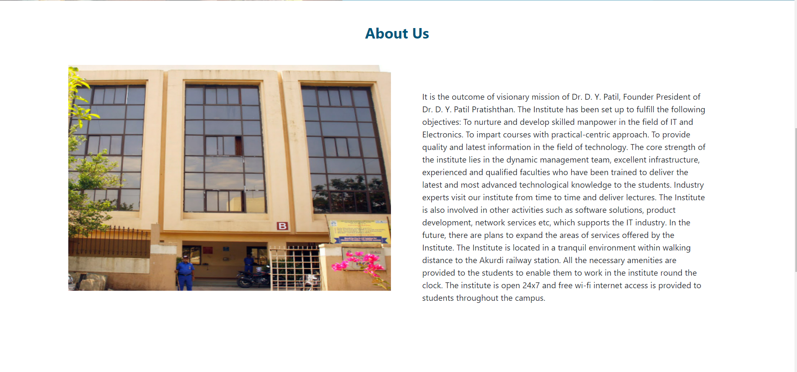

**Footer**

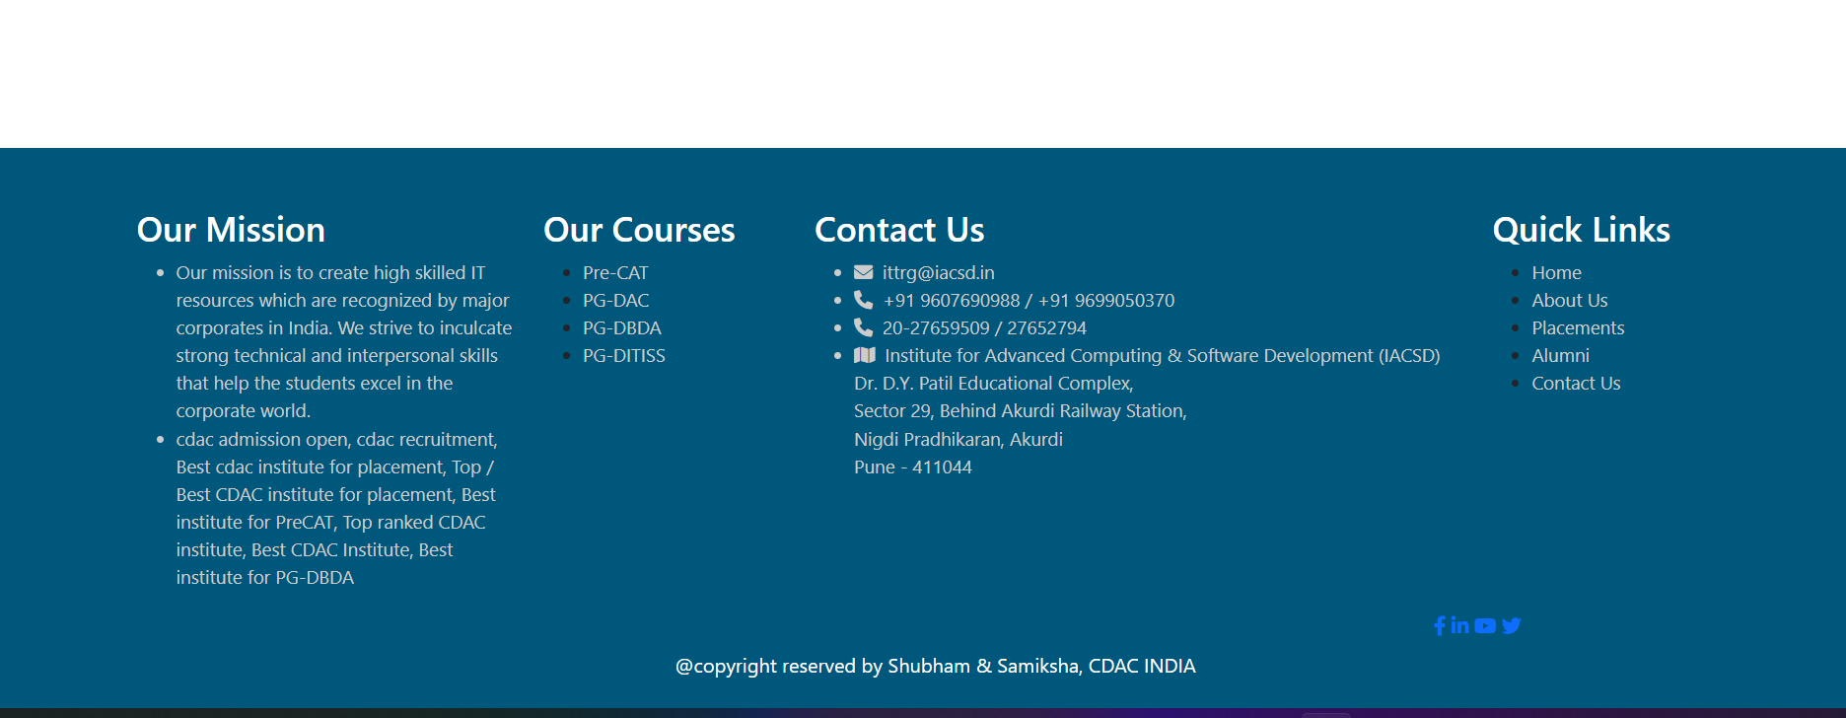

**6.1 Admin flow :**

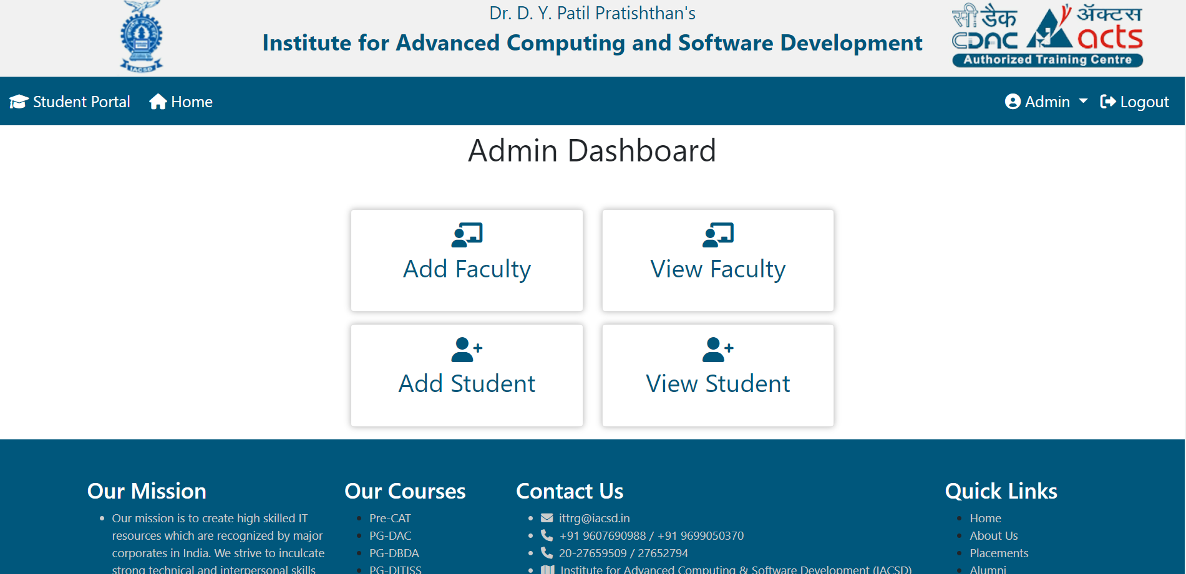

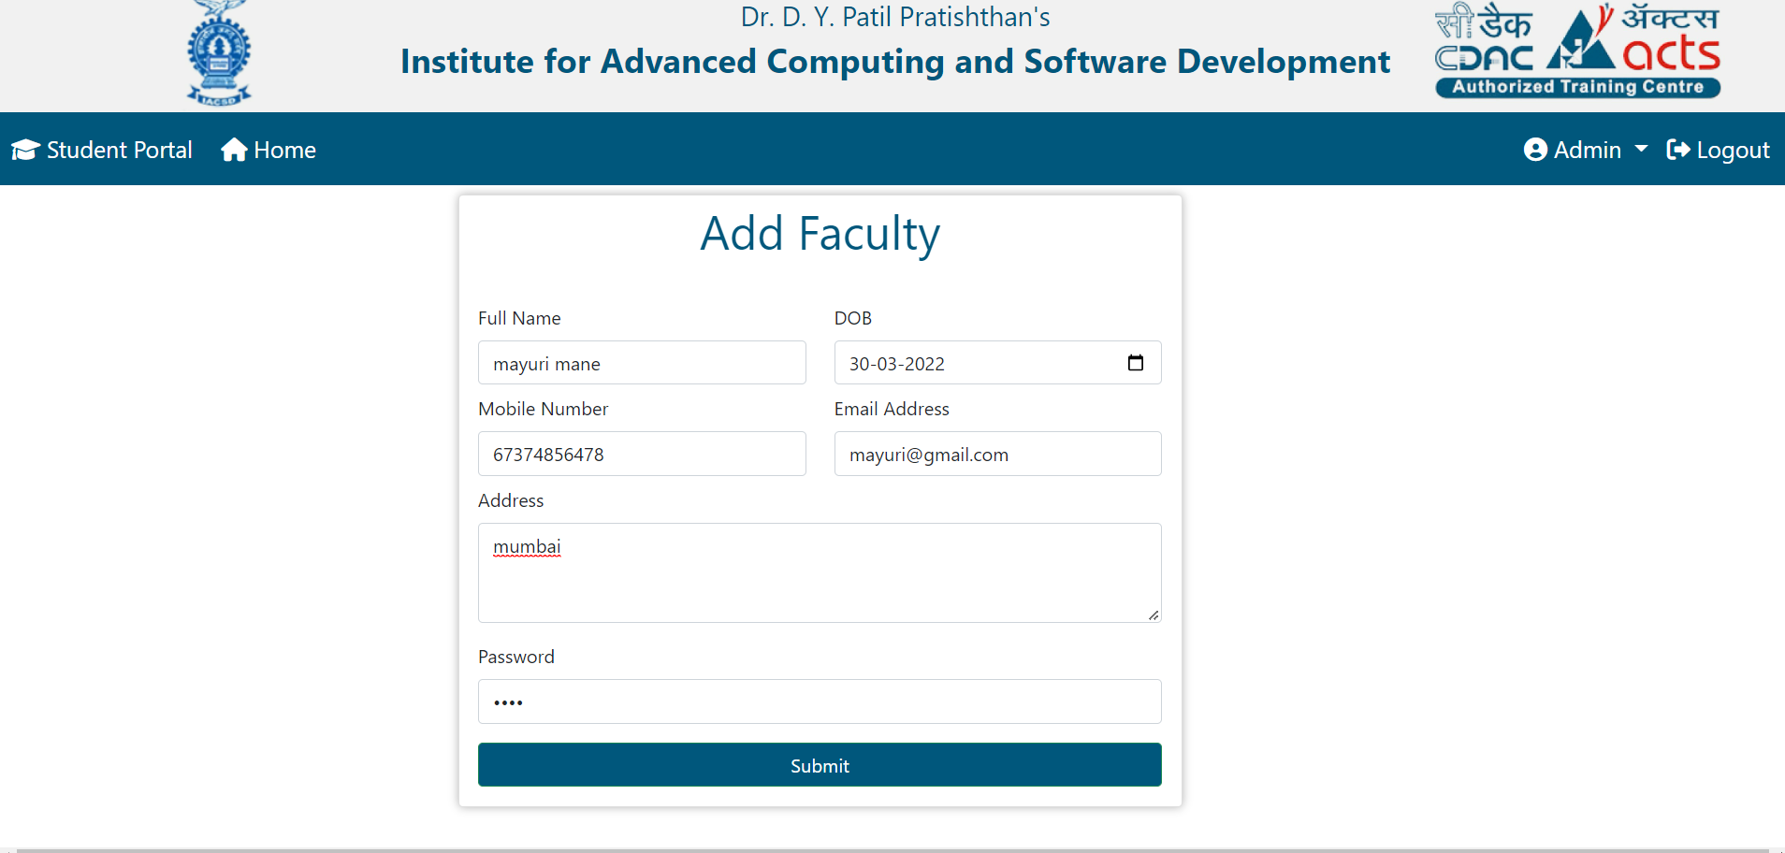

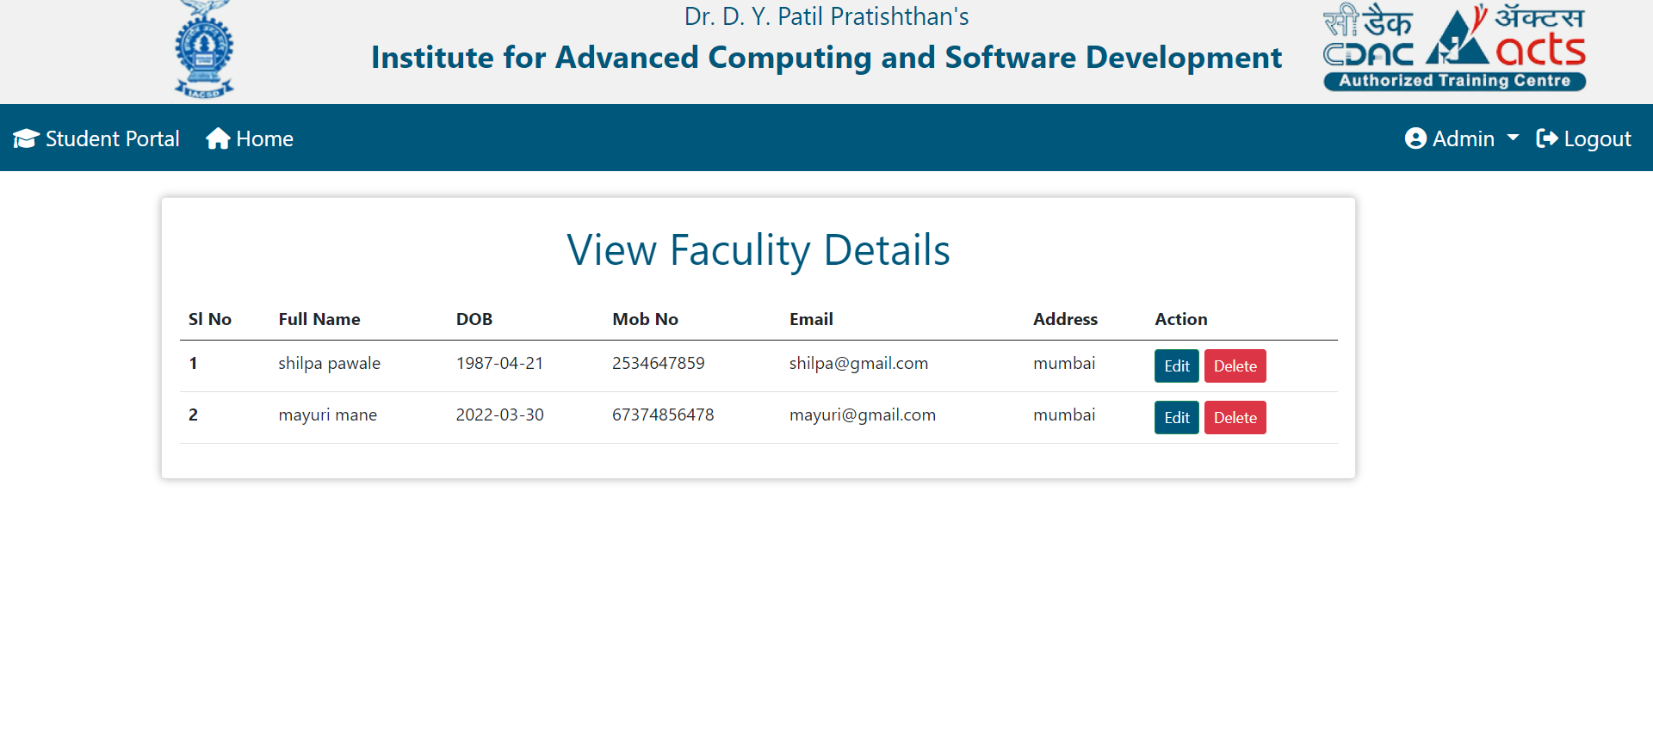

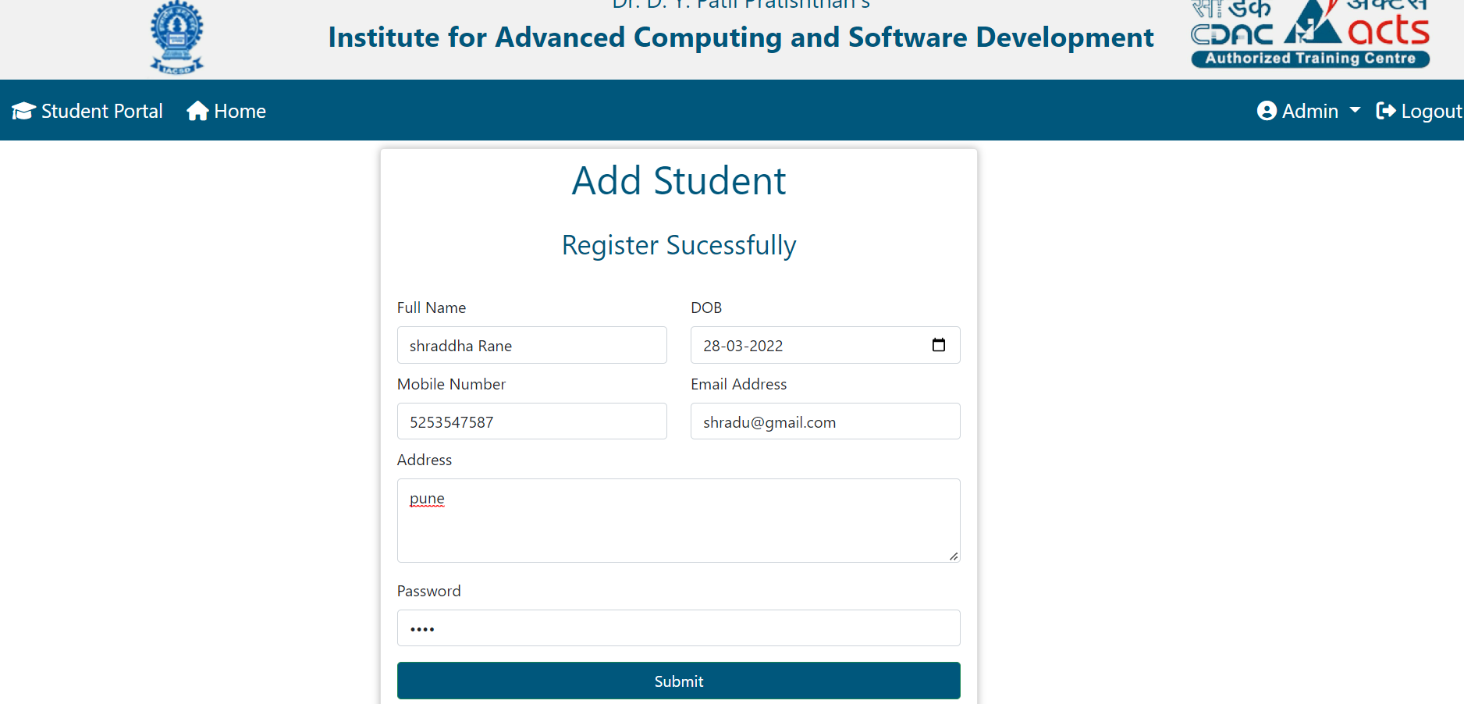

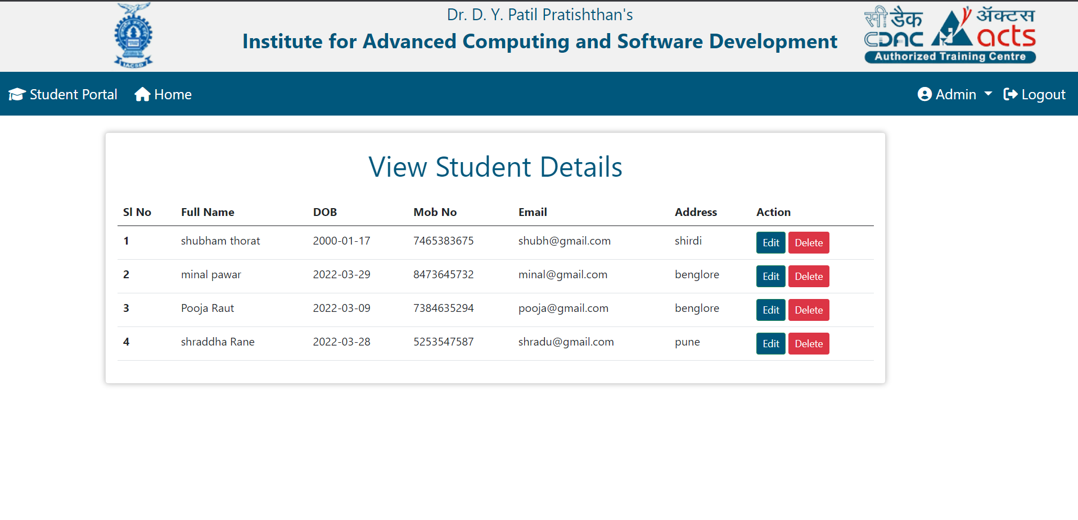

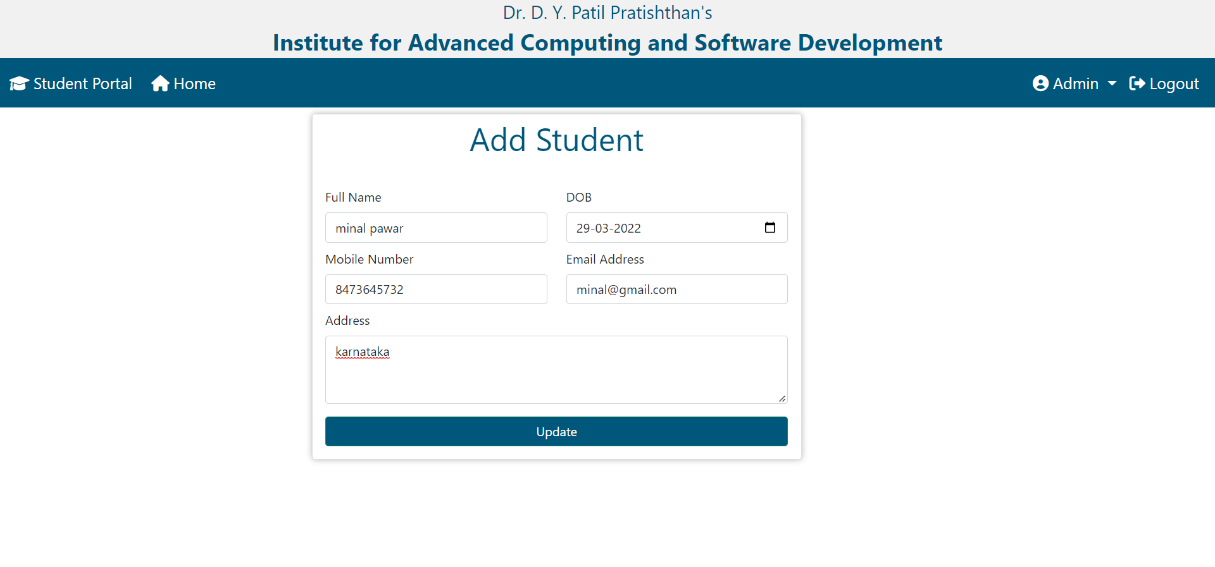

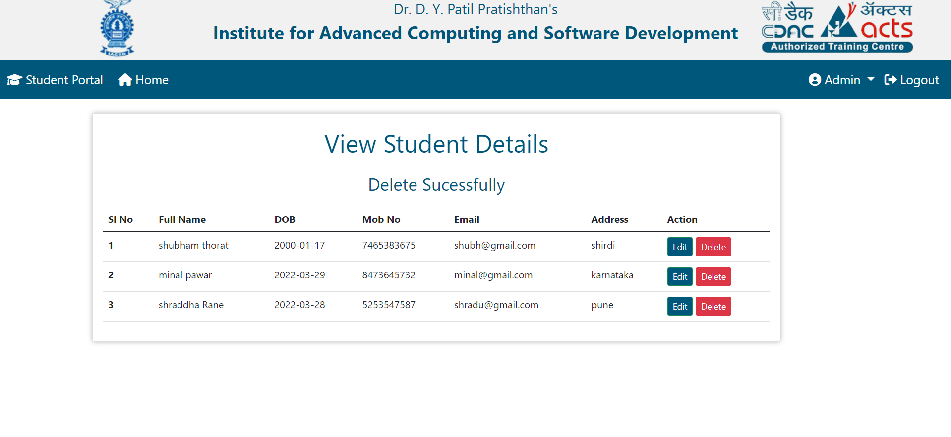

**6.2 Faculty flow :**

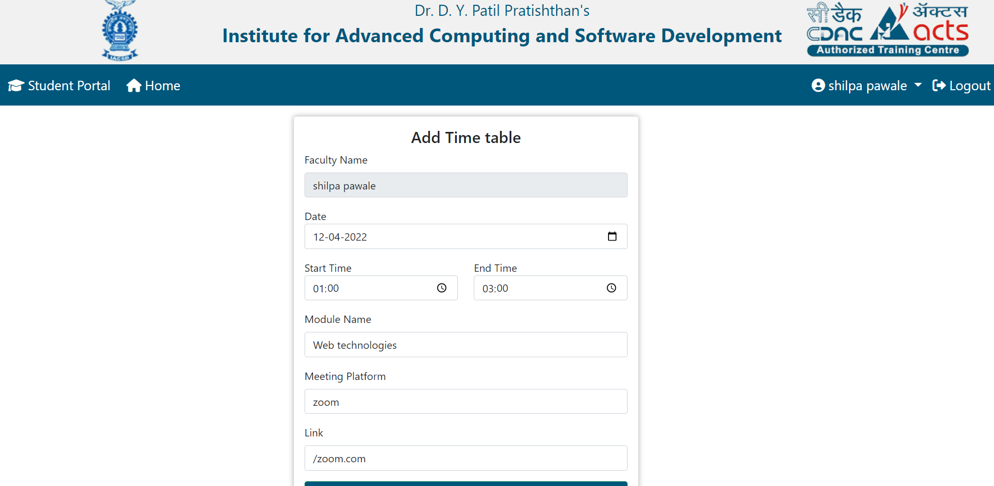

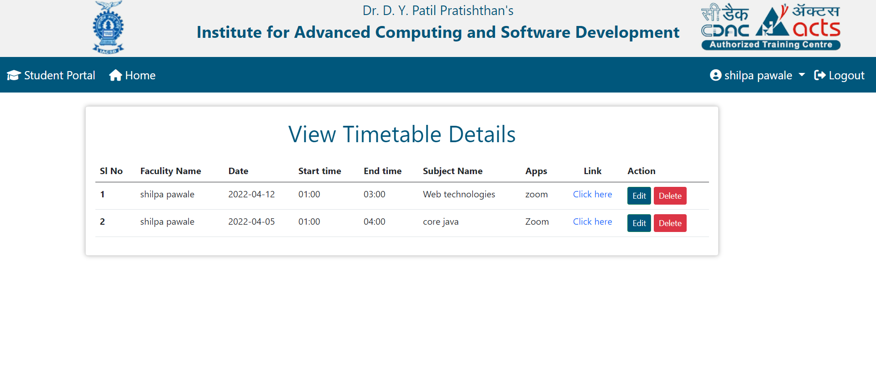

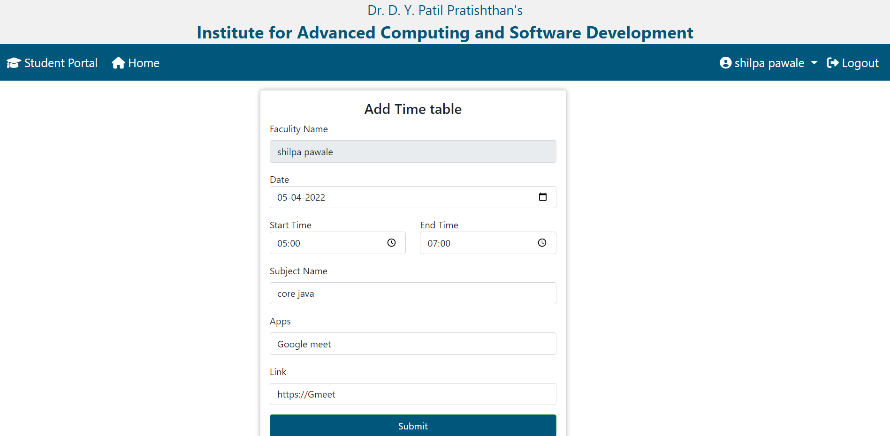

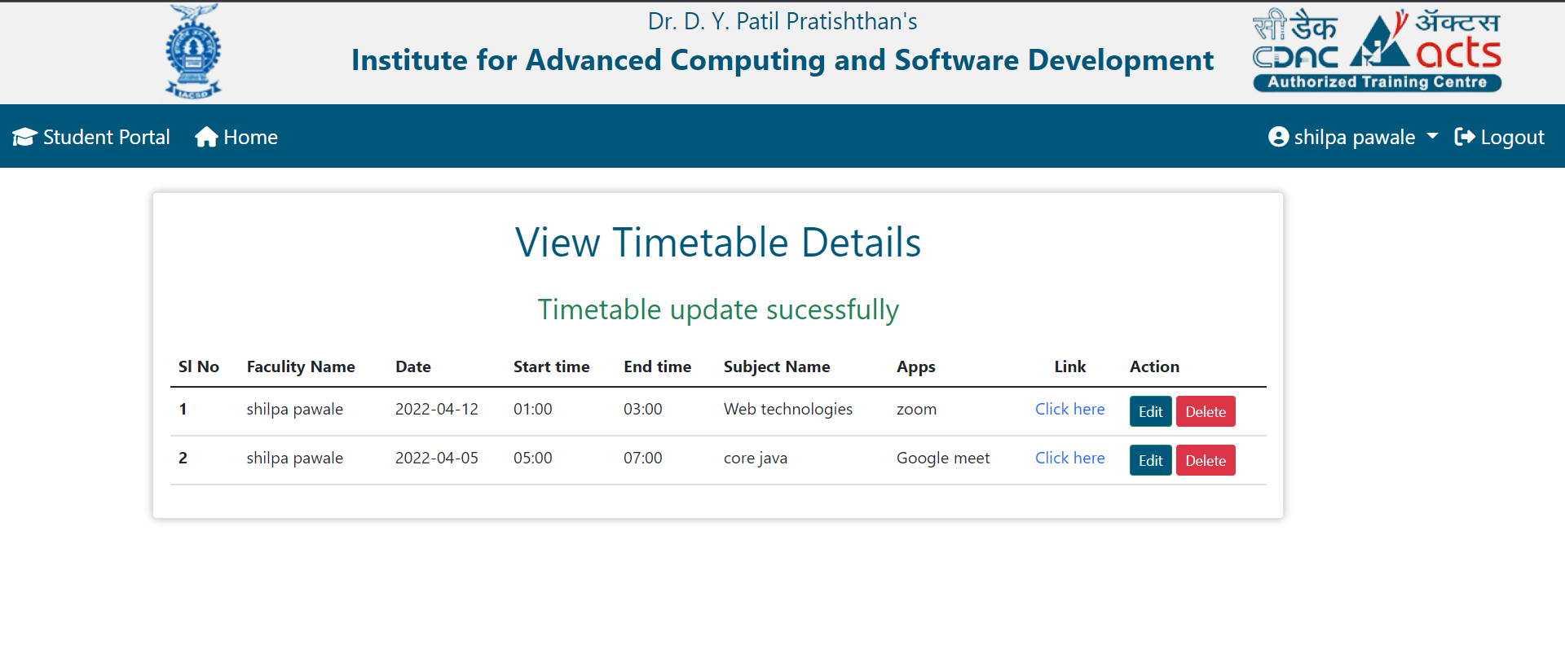

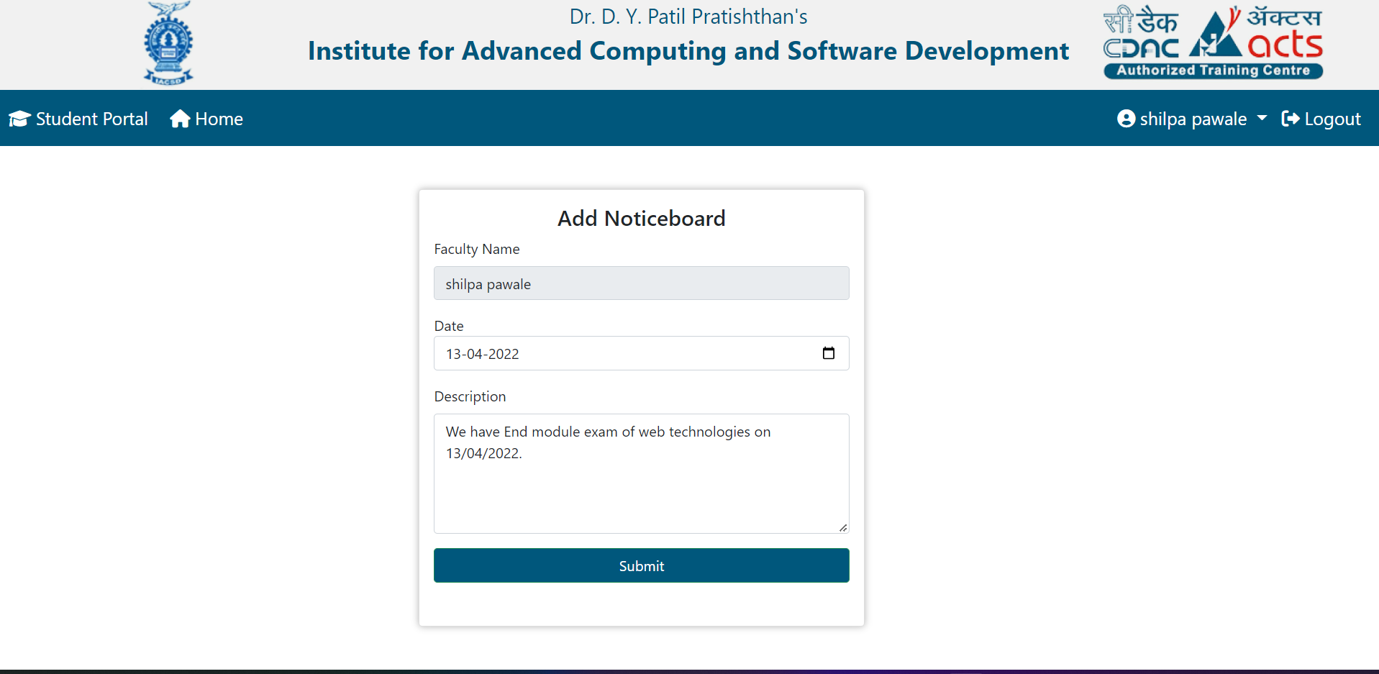

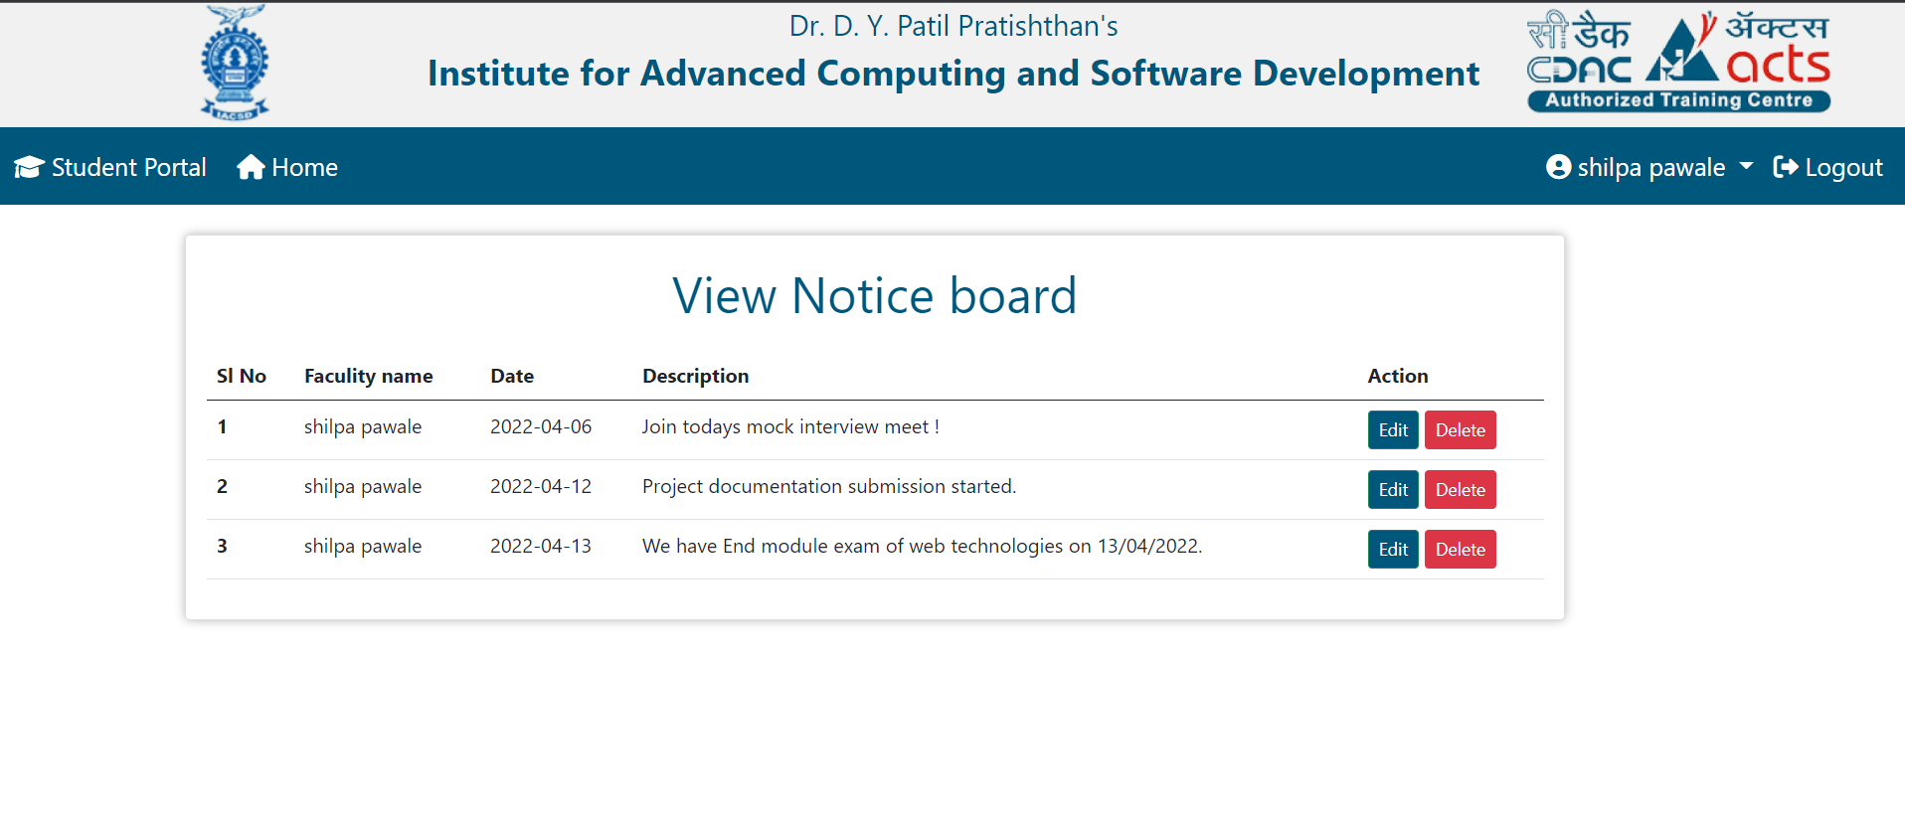

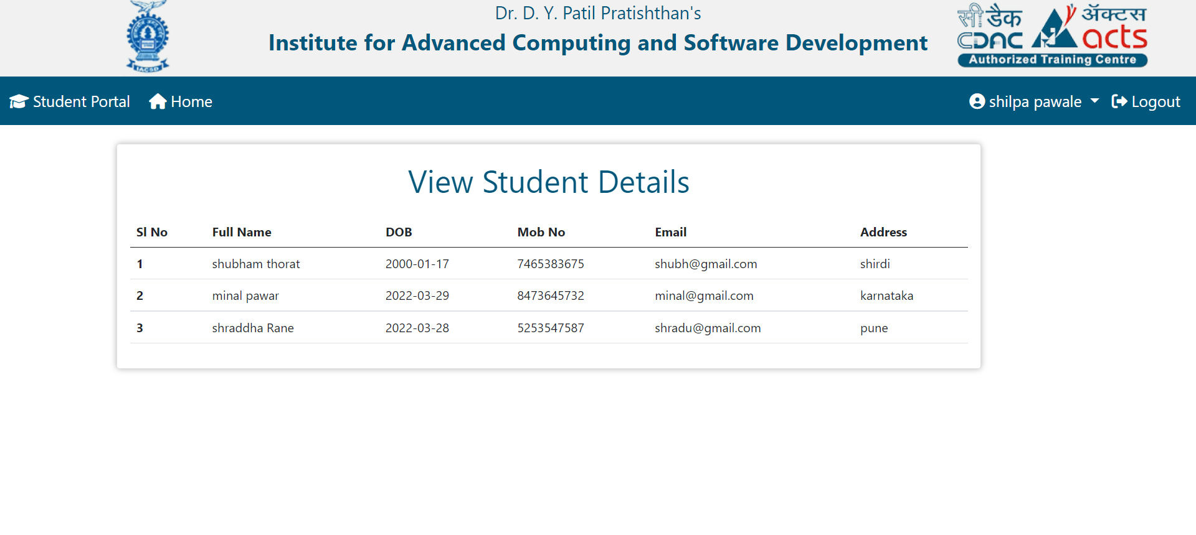

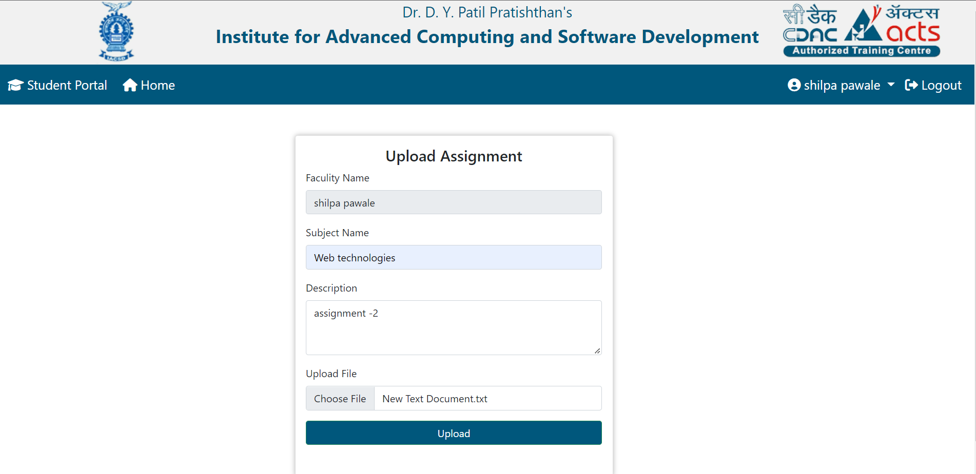

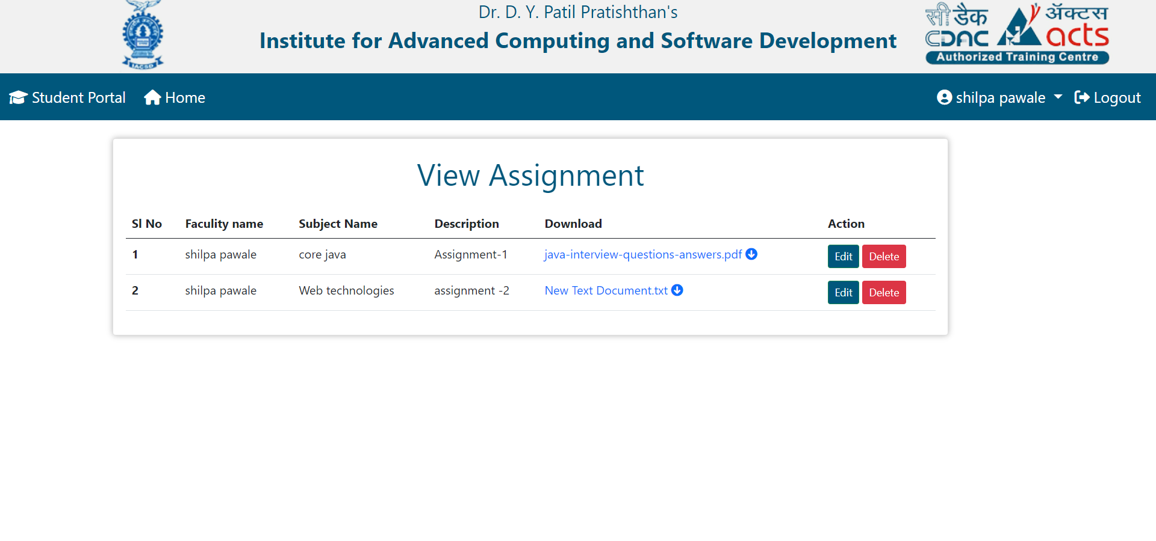

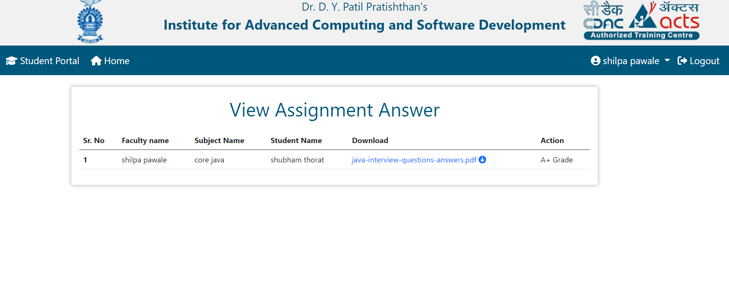

**6.3 Student flow :**

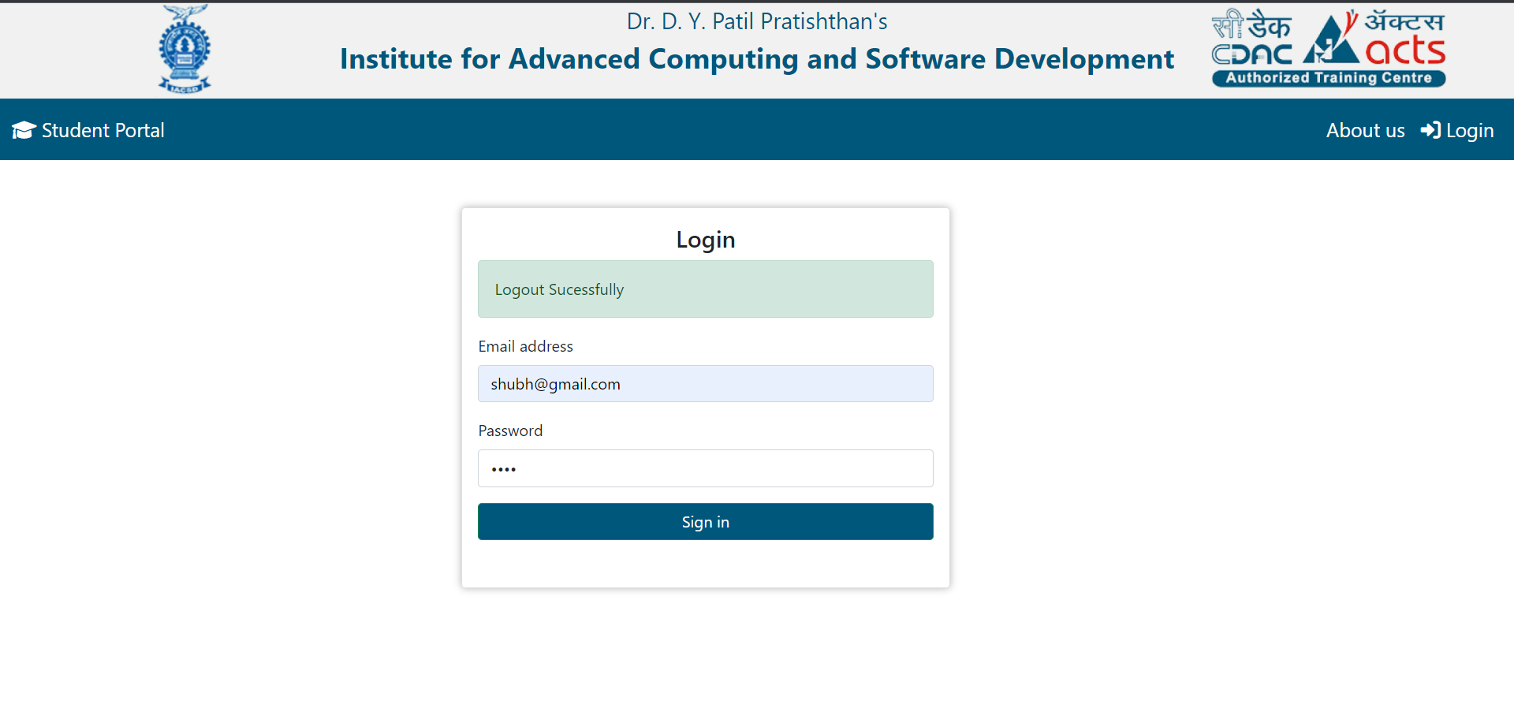

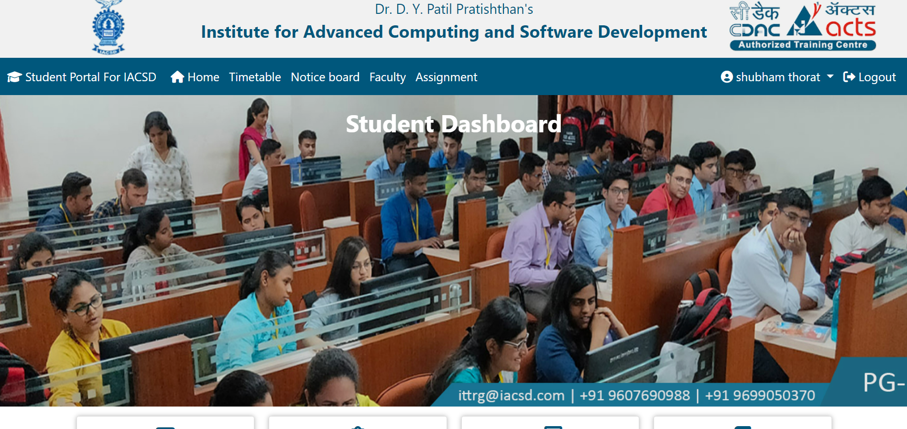

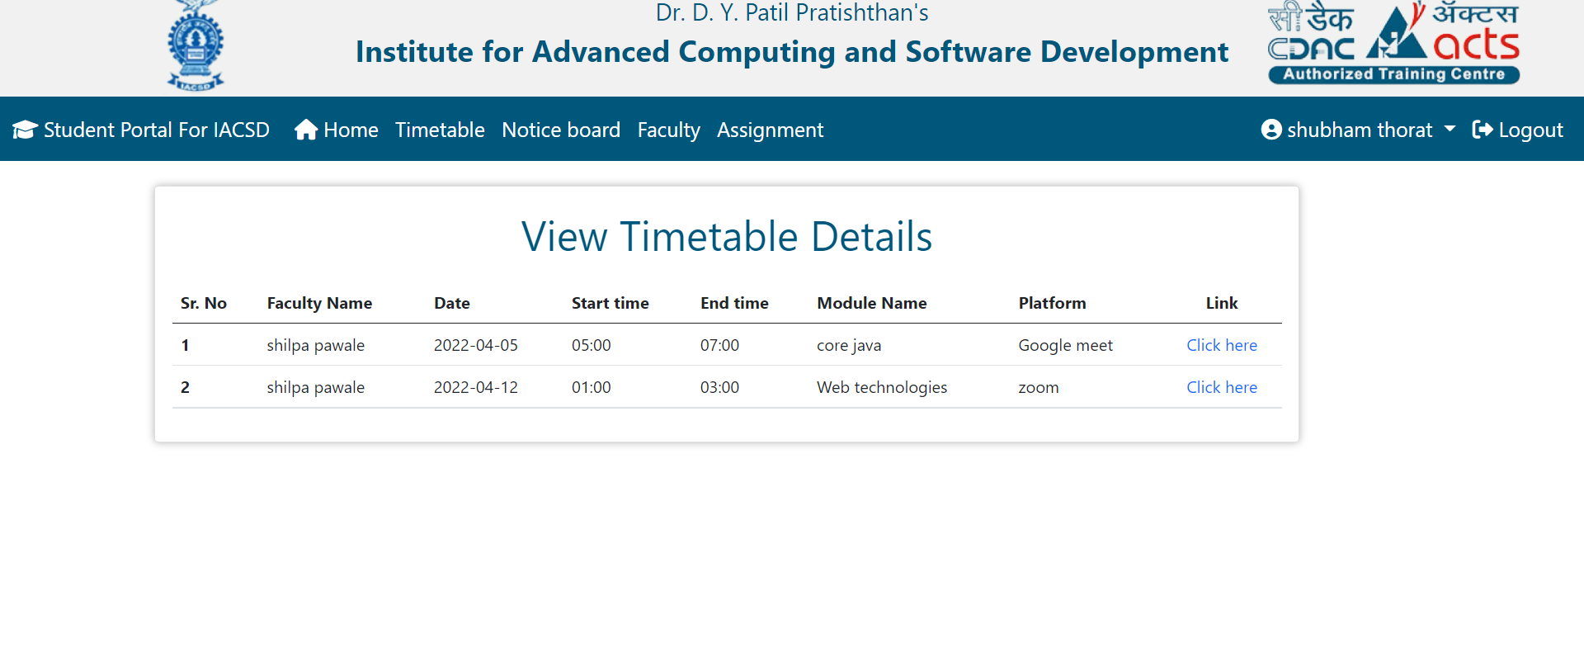

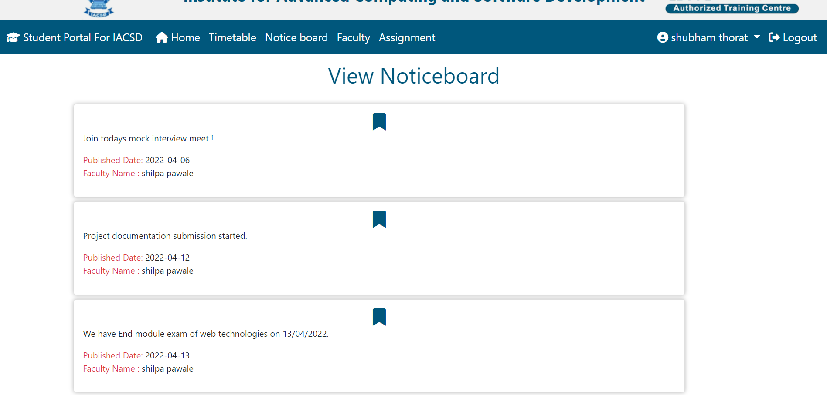

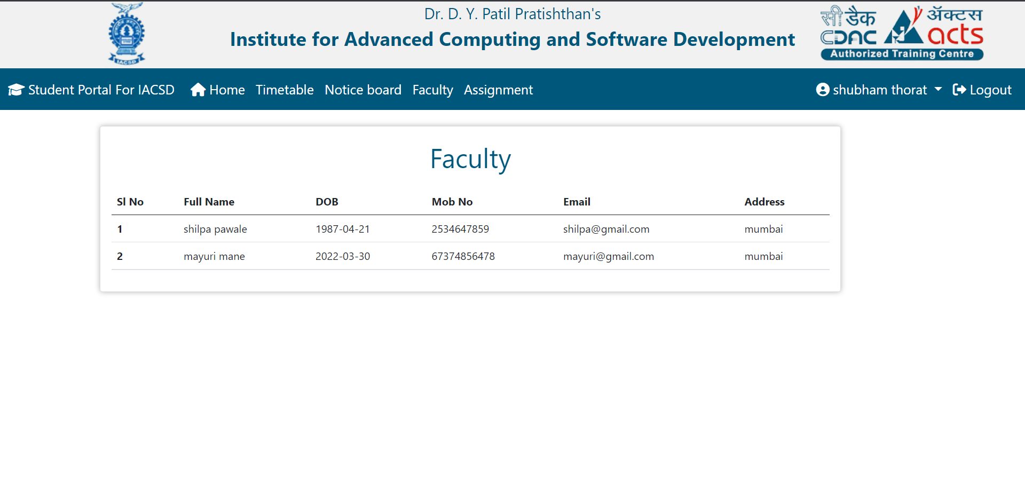

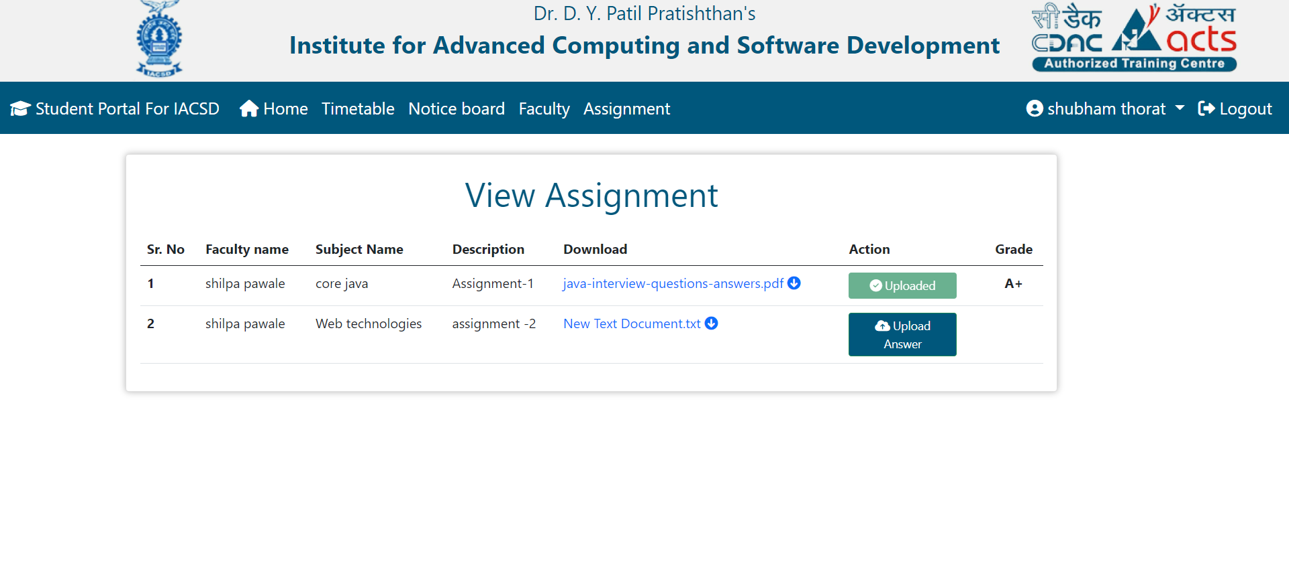

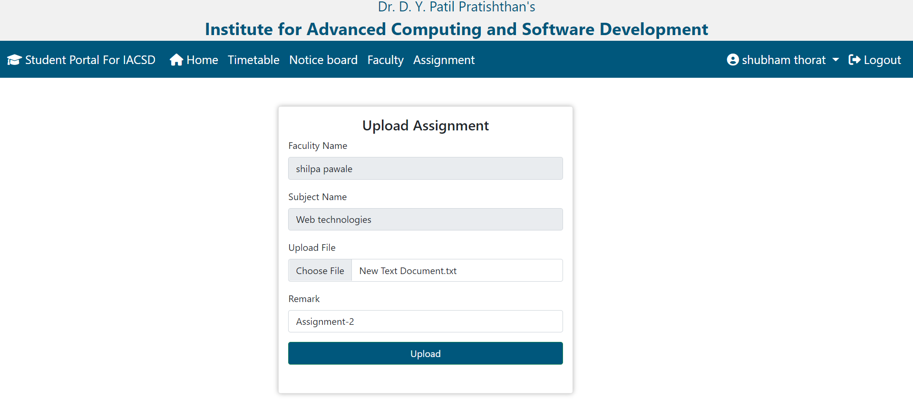

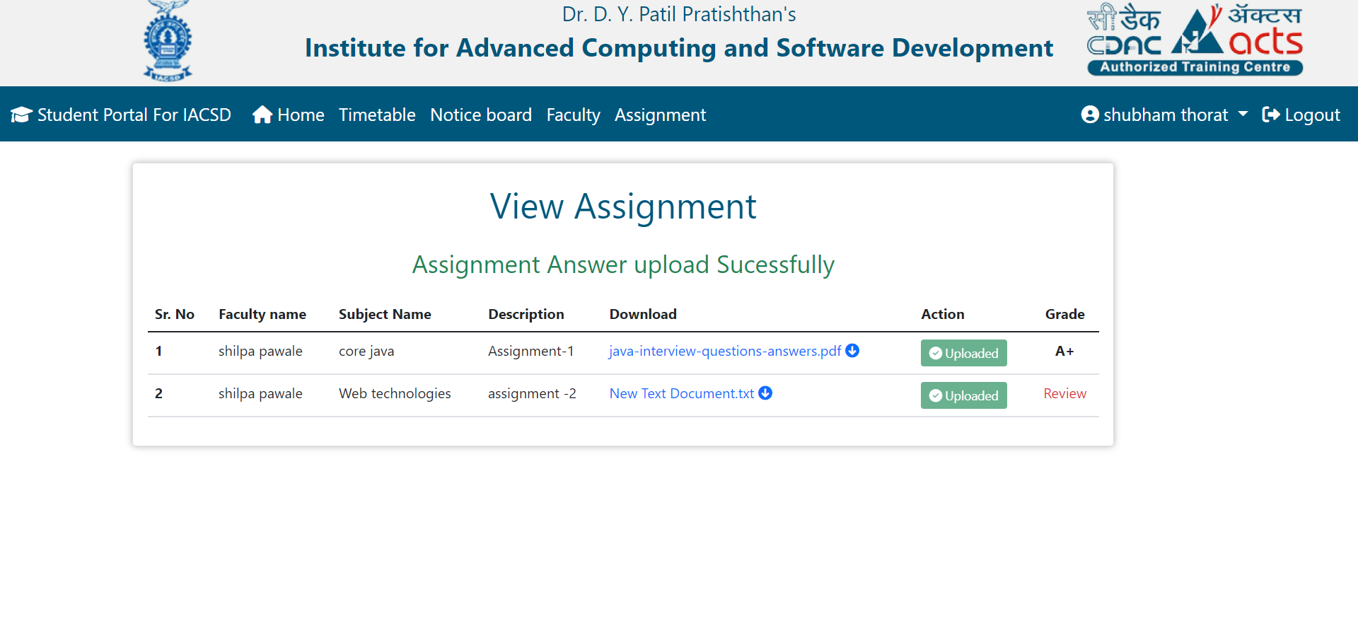

**7. Conclusion**

Student portal for IACSD puts forth the actual working of a institute. Admin modules, Assignment upload and download, grade distribution, adding noticeboard and timetable etc these are some important modules from our project. User who is going to access this website should be first associated with IACSD.

# 6.1 Future Scope

This project can be enhanced further by adding :

- Attendance marking of the students

- end module exam

- we can also provide mock tests to the students

-faculty can give results of mock tests and end module exam.

The software is flexible enough to be modified and implemented as per future requirements. We have tried our best to present this free and user–friendly website to Faculty as well as students.

# References

1. [www.wikipedia.com](http://www.wikipedia.com)
2. [www.w3school.com](http://www.w3school.com)
3. [www.javatpoint.com](http://www.javatpoint.com)

**ONLINE REFERENCE**

1. Z. Kai, “Design and implementation of college students' entrepreneurship management system based on B/S structure,” *RISTI - Revista Iberica de Sistemas e Tecnologias de Informacao*, vol. 2016, no. 17, pp. 102–113, 2016.View at: [Google Scholar](https://scholar.google.com/scholar_lookup?title=Design%20and%20implementation%20of%20college%20students%27%20entrepreneurship%20management%20system%20based%20on%20B/S%20structure&author=Z.%20Kai&publication_year=2016)
2. S. R. Bharamagoudar, R. B. Geeta, and S. G. Totad, “Web based student information management system,” *International Journal of Advanced Research in Computer and Communication Engineering*, vol. 2, no. 6, 2013.View at: [Google Scholar](https://scholar.google.com/scholar_lookup?title=Web%20based%20student%20information%20management%20system&author=S.%20R.%20Bharamagoudar&author=R.%20B.%20Geeta&author=&author=S.%20G.%20Totad&publication_year=2013)